Kubernets install

------------------------------------

➡curl -LO https://dl.k8s.io/release/v1.32.0/bin/linux/amd64/kubectl

➡sudo install -o root -g root -m 0755 kubectl /usr/local/bin/kubectl

➡chmod +x kubectl

➡mkdir -p ~/.local/bin

➡mv ./kubectl ~/.local/bin/kubectl

➡kubectl version --client

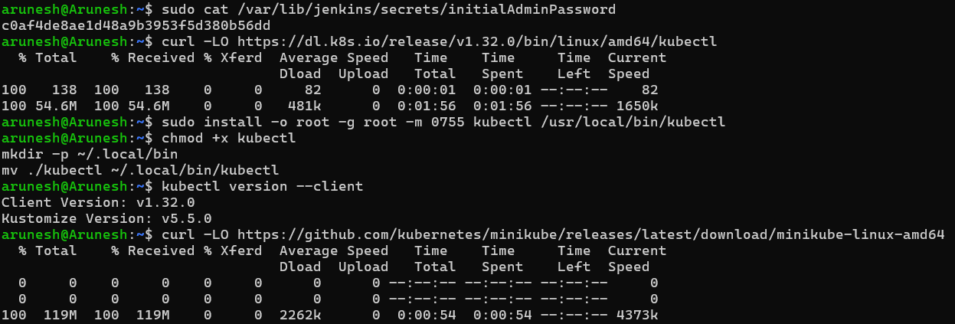

---------------------------------------------------------------------------------------------------------

➡minikube installation

➡curl -LO https://github.com/kubernetes/minikube/releases/latest/download/minikube-linux-amd64

➡sudo install minikube-linux-amd64 /usr/local/bin/minikube && rm minikube-linux-amd64

➡minikube start

